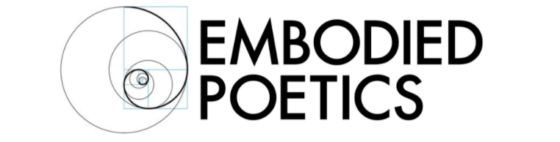

STORY LAB WITH JONATHAN YOUNG JUNE 10 - 14

‘I find that most people know what a story is until they sit down to write one.’ Flannery O'Connor

Story Lab: Learn the hidden principles of storytelling, and develop your own story idea from scratch to an outline.

People often think that creating a story happens in a similar way to how we consume them – where one exciting thing follows another from start to finish. But in fact, crafting a truly satisfying story requires a fundamentally different, structural approach that takes into account why human beings love and need stories so much.

Your skeleton is invisible, but without it you’d have no form or function. Similarly, all good stories have hidden structures that are fundamental to their success, structures that create meaning.

This week will be about learning these specific structural tools and ways of thinking about story, and then using these tools simply and rigorously to develop your own original story from first idea to basic outline.

The course is suitable for anyone who wants to learn how to craft compelling, dramatic or comic stories – fiction and non-fiction writers, storytellers, playwrights, theatre-makers and screenwriters. It is an introduction and overview that teaches the habits of mind you will need to become a successful teller of stories; the rest is practice and application.

During the first half of each afternoon, we will cover the fundamental principles of how to create original stories through tuition, discussion, exercises and examples from film, theatre and fiction; in the second half of each session, we will focus on helping each person develop and refine their own story idea through exercises, coaching and additional teaching. Exercises will be set each day, outside of class.

You do not need to start the week with a story idea, however, you are welcome to bring an idea you are already working on.
​
Areas we will cover will include:
​
- what stories are for and why people crave them
- how to engage your audience so they care – and keep caring
- what key questions to ask when designing a story
- how to create memorable characters and why you have to make life really difficult for your protagonist
- develop an organic 'unity of action' that leads to a memorable and satisfying ending
- find a central dilemma that can help drive your story
- understand theme, world and genre
- learn how structure and character are two sides of the same coin ​
- understand text and subtext
- ways of thinking about scenes and how to link them
- find ways of developing your own authentic voice
- create the key steps of your story and pitch it

Biography

Jonathan is an experienced scriptwriter, with a background in theatre and movement. After training with Jacques Lecoq in Paris, he ran a touring theatre company for 11 years from 2001-12, creating and writing original work, as well as working with other UK companies as a performer, director and award-winning dramaturg.

He has been screenwriting since 2014; in 2016 he co-wrote the short film, ‘Padlock’ which won Best Film at the Bottle Smoke Film Festival and Best Thriller at the New Renaissance Film Festival 2017. He is currently developing a low-budget feature ‘The Retreat’. He also works as a movement/theatre teacher at Embodied Poetics and LAMDA, as a Feldenkrais practitioner, and a theatre director and dramaturg.

Course Details
June 10- 14
M-R 3:30- 6 PM, F 2:30 – 5 PM
Chisenhale Dance Space, 68-84 Chisenhale Road, London E3 5QZ
Before 1/3/19: £125
After 1/3/19: £175

Embodied Poetics is a company limited by guarantee
Registered in England number 11185216
Registered Office: Registered Address:
93, Green Dragon Lane, Winchmore Hill, London, N21 2NL, England

