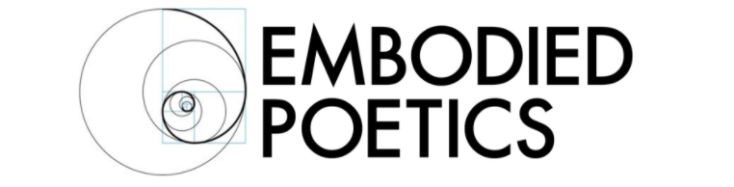

MYTH-MAKING FOR ARTSITS AND HEALERS: TWO WORKSHOPS WITH AMY RUSSELL
JUNE 3-7, 10-14, 2019

Mythopoetics is a new approach to the development of healing arts as well as the art of psychic healing. It integrates Jungian and Gestalt approaches to therapy with physical, creative performance practices.

Taking as its point of departure the Gestalt tenet that awareness and creativity are the ways in which the human personality both develops and heals itself, Mythopoetics integrates a Jungian approach to myth, suggesting that mythic scenarios reveal growth points and transformational opportunities through their narrative structures.

In our changing times, there is the danger that mythic narratives, which are culturally relative, may be perceived and practiced as religious or quasi-religious universal givens. Gestalt revisions Jungian myths and archetypes as sedimentary cultural patterns, not universal absolutes.

In the work of Mythopoetics, bodies – with all their individual differences and unique inflections - are considered to be the first mythic resource. Bodies’ structures and movements are considered to be reliable reference points in the process of “mythopoesis”, the classical term which refers to the creation of myth.

Mythopoetics invites artistic and healing practitioners - through physical performance practices - to devise their own mythic elements. These mythic elements then evolve into dramatic forms, first solo, then in dyads, then in small groups. Throughout the work, dual attention is given both to the safety of a therapeutic boundary and to artistic freedom, arising from the transpersonal nature of poetry and metaphor.

Embodied Poetics Summer Course 2019 is a two-week introduction to Mythopoetics as a healing and artistic practice. The two weeks can be taken separately or together: both will lay a foundation for the practice in the first session.

Week 1: Intrapersonal Myths
In this weeklong course, the therapeutic boundary will be set for personal work to occur within a supportive group. Physical and creative exercises and themes will invite participants to generate, explore, play with and transform personally held mythic structures.

Week 2: Group-level Myths
This second week will again lay the foundation for the work of Mythopoetics, and the boundary will be set for a group-level process in which transpersonal and poetic processes are at play. Dyadic and subgroup mythopoetic exercises will be offered, and performances within the larger group will invite the group-as-a-whole to see itself as an agent of awareness and change.

About Amy

Amy is the Founder and Pedagogic Director of Embodied Poetics. She is a senior teacher in the pedagogy of Jacques Copeau/Suzanne Bing and Jacques Lecoq. She is also a qualified and accredited Gestalt Therapist (UKCP) and has a solo practice as well as working in group facilitation.

Amy has taught the Embodied Poetics Pedagogy for over twenty years. She was a pedagogic student of Jacques Lecoq in 1997-1998. She went on to found the Naropa Unversity MFA in Lecoq-Based Physical Theatre, which she led and taught for nine years. She pedagogically co-founded the London International School of Performing Arts (LISPA) in 2003. She teaches workshops in the pedagogy, as well as its interface with Gestalt practice at schools and conservatories internationally.

Course Details
June 3-7, 10- 14
M-R 1 – 3:30, F 9-12 – 2:30
Chisenhale Dance Space, 68-84 Chisenhale Road, London E3 5QZ
Before 1/3/19: £125, for both weeks, £225
After 1/3/19: £175 per week, for both weeks, £325

Embodied Poetics is a company limited by guarantee
Registered in England number 11185216
Registered Office: Registered Address:
93, Green Dragon Lane, Winchmore Hill, London, N21 2NL, England

