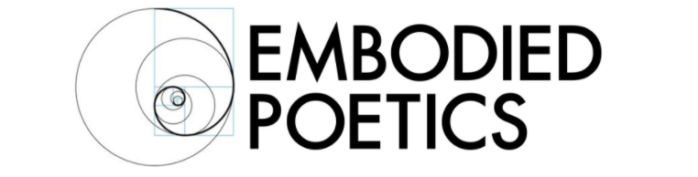

MYTH-MAKING FOR ARTSITS AND HEALERS: TWO WORKSHOPS WITH AMY RUSSELL
JUNE 3-7, 10-14, 2019

Mythopoetics is a new approach to artistic practice as well as to the art of psychic healing. It integrates Jungian and Gestalt approaches to therapy with physical, creative performance practices.

Taking as its point of departure the Gestalt tenet that awareness and creativity are the ways in which the human personality both develops and heals itself, Mythopoetics integrates a Jungian approach to myth, suggesting that mythic scenarios reveal growth points and transformational opportunities through their narrative structures.

In our changing times, there is the danger that mythic narratives, which are culturally relative, may be perceived and practiced as religious or quasi-religious universal givens. Gestalt revisions Jungian myths and archetypes as sedimentary cultural patterns, not universal absolutes.

In the work of Mythopoetics, our bodies – with all their individual differences - are considered to be the first mythic resource. Our bodies’ structures, movements, and memories will be our reference points in the process of “mythopoesis”, the classical term which refers to the creation of myth. We will delve into our physical experience in search of its wisdom – we will let our bodies do the talking.

We will then encourage these “voices” to develop into different forms, becoming mythic elements: first solos, then dyads, then work in small groups. Throughout the process, dual attention will be given both to the safety of a therapeutic boundary and to the artistic freedom that arises from the transpersonal nature of poetry and metaphor.

Embodied Poetics Summer Course 2019 is a two-week introduction to Mythopoetics as a healing and artistic practice. The two weeks can be taken separately or together: both will lay a foundation for the practice in the first session.

Week 1: Intrapersonal Myths
In this weeklong course, the therapeutic boundary will be set for personal work to occur within a supportive group. Physical and creative exercises and themes will invite participants to generate, explore, play with and transform personally held mythic structures.

Week 2: Group-level Myths
This second week will again lay the foundation for the work of Mythopoetics, and the boundary will be set for a group-level process, in which transpersonal and poetic processes are at play. Dyadic and subgroup mythopoetic exercises will be offered, and performances within the larger group will invite the group-as-a-whole to see itself as an agent of awareness and change.

About Amy

Amy is the Founder and Pedagogic Director of Embodied Poetics. She is a senior teacher in the pedagogy of Jacques Copeau/Suzanne Bing and Jacques Lecoq. She is also a qualified and accredited Gestalt Therapist (UKCP) and works with individuals as well as working in group facilitation.

Amy has taught the Embodied Poetics Pedagogy for over twenty years. She was a pedagogic student of Jacques Lecoq in 1997-1998. She went on to found the Naropa Unversity MFA in Lecoq-Based Physical Theatre, which she led and taught for nine years. She pedagogically co-founded the London International School of Performing Arts (LISPA) in 2003. She teaches workshops in the pedagogy, as well as its interface with Gestalt practice, at schools and conservatories internationally.

Course Details
June 3-7, 10 - 14
M-R 12:30 – 3:00, F 11:30 – 2:00
Chisenhale Dance Space, 68-84 Chisenhale Road, London E3 5QZ
Fee per week: £125
Both weeks: £225

