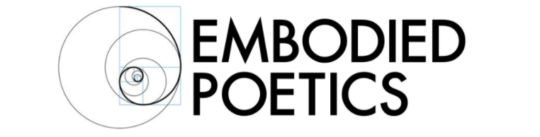

INTEGRATED ACTING: INTENSIVE WITH ED WOODALL JUNE 3-7, 10-14

This two-week workshop on Ed Woodall’s Integrated Acting is a wonderful opportunity to explore a unique, embodied, approach to acting.

Integrated Acting is an experienced actor/actor trainer’s response to real difficulties in acting with the highest level of integrity possible. Ed came from a physical theatre which often fell short when it came to vocal expression and he has also performed in many naturalistic scenarios where actors are often stifled, physically. Integrated Acting is an approach which brings intention, movement and voice into one integrated whole and bridges the gap between sometimes opposing “camps”. It is a process where Stanislavski and Lecoq could be said to come together.

The first week will focus on transformation of the self. How do you truly act from another character’s perspective? How do you create that “bridge” between thinking about the character and embodying it? And crucially, how do you maintain that character’s state of mind as you study the text, rehearse the piece and finally perform for stage or film?
Ed’s method will take you step by step, through the physical and vocal abstractions that will get you beneath the surface and into the “essence” of the character.
You will also be introduced to Integrated Acting’s unique ways of notating discoveries, Ideograms and The Grid.

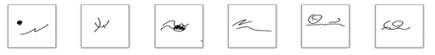

The second week will focus on dialogue. Even if you have done brilliant physical preparation for the character, can you ensure that they will have their own authentic voice? The preparation in abstract movement and abstract sound in week one will put you in a great position to feel like your character has its own state of mind and its own voice. Then Ed will introduce you to the most challenging part of the process and perhaps the most rewarding.
With a starting point of “actioning” (from the Stanislavskian methodology), you will then learn how to place your embodied attention into the other character. It is a remarkable way of bringing life to your work and going beyond the self-consciousness that can scupper any acting.
Ed will be exploring a number of new aspects of this embodied exchange which he developed at the prestigious Oxford School of Drama; these will include conscious and subconscious drives, dreaming and fearing, and completing the circle.

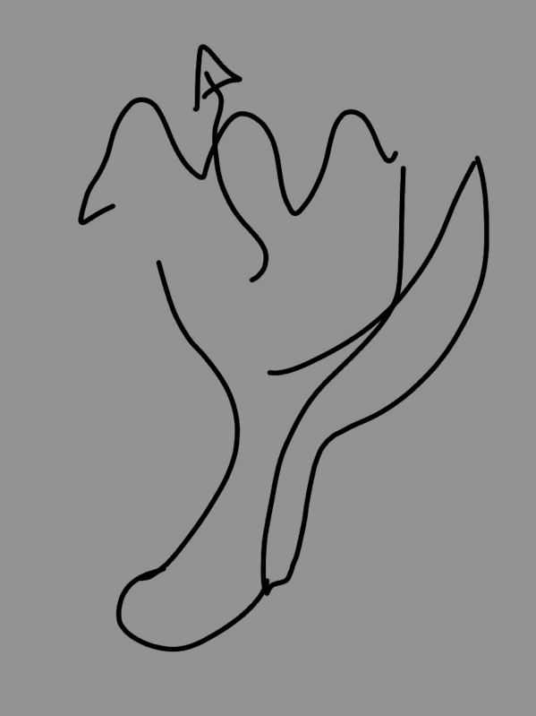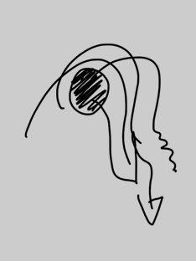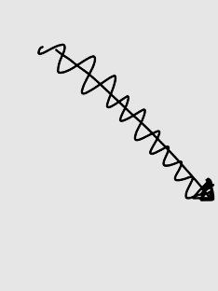

About Ed
Ed is an actor, an award-winning director and now a Feldenkrais Practitioner. Ed studied English Literature and Language at Manchester University; joined the Manchester Community Circus and started his pedagogic journey by teaching clowning to prisoners in the infamous Strangeways Prison.

Ed studied two years with Jacques Lecoq in Paris and followed that by running the theatre company “Partis-Pris” before acting in theatre, TV and film, culminating in several roles alongside Gwyneth Paltrow and Andy Serkis. Ed then returned to his firs love; devised theatre. He collaborated and performed in shows made by Complicité, Improbable and Kneehigh amongst others and was in the team who came up with puppeteering for Warhorse.

In 2004, Ed moved into teaching on a full-time basis. First, the European Theatre Artists course at Rose Bruford and the Contemporary Theatre course at East 15.

Since moving to Oxford 10 years ago, Ed has focused his energy on teaching Lecoq Pedagogy with a Stanislavskian framework at the Oxford School of Drama, which was recently voted as one of the top five acting conservatories in the world.

Course Details
June 3-7, 10- 14
M-R 10 – 12:30, F 9-11:30
Chisenhale Dance Space, 68-84 Chisenhale Road, London E3 5QZ
Fee: £250

Embodied Poetics is a company limited by guarantee
Registered in England number 11185216
Registered Office: Registered Address:
93, Green Dragon Lane, Winchmore Hill, London, N21 2NL, England

