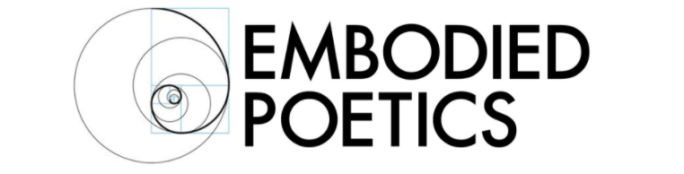

THE LABORATORY FOR EMBODIED SPACE

SUMMER INTENSIVE JUNE 2019

The Laboratory for Embodied Space explores the fundamental relationship between movement and the architectural space, between the body and the space it inhabits. In a world increasingly dominated by ‘digital’ interaction and the need for immediacy and instant response to any impulse, The Laboratory gives participants an opportunity for reflection and rediscovery of the physical space around us and through revealing that space, the ability to start constructing it. The heightened awareness of the space between, above, beneath, behind and in front ultimately allows us to also reveal the space within us.

The hands-on nature of The Laboratory enables participants to go on a journey of discovery through their bodies, their feelings. These discoveries are then translated into drawings and 3D constructions, which invite movement from the spectator or demand to be moved in the space. This process allows the participants to free themselves from an intellectual approach to creating and to access a fundamental level of interconnection.

In The Laboratory for Embodied Space, Aurelian Koch recreates and advances the breakthrough project of Jacques Lecoq in the realm of architecture, scenic design and the construction of scenic objects, which he referred to as “portable architecture”, in the Laboratory for the Study of Movement (Laboratoire de l’Étude de Mouvement or LEM) at the École Lecoq. These objects could be seen as larval forms of pre-existing categories - stage sets, masks, full-body masks and puppets - however their open-endedness reveals so much about the body in movement and its relationship to space that it is also an excellent advanced training for physical performers, as well as a crucial training for directors, scenographers and choreographers.

In this intensive summer course, participants will be guided on a journey through increasingly focused exercises and tasks, starting with movement in the space, exploring both the movement of the body as well as moving simple objects.

They will then focus the exploration on the dynamic of colours: what is the architectural space of a particular colour, how big is it, how fast, how long does it last?

Through drawings and 3D construction, they will deepen their understanding and emotional response to colours, going far beyond cultural meaning or intellectual associations that they may have.

This knowledge will then be applied to a series of exercises to explore the space within each of us individually and will ultimately result in the construction of a sculptural mirror image, turning our bodies inside out, enabling us to access a level of personal inspiration and physical truth from within ourselves.

This Intensive Summer Course will engage participants in movement exercises, charcoal drawings and the basic construction of space with simple materials. It does not require previous experience in the visual arts, however experienced artists will find the approach novel and revelatory.

About Aurelian:

Aurelian Koch trained at the École Jacques Lecoq in Paris, where he also studied at the LEM. In 1993, he co-founded Bouge-de-la Theatre in Oxford, where he was Joint Artistic Director for 12 years. He produced, designed and toured 7 professional shows and worked with young people on over 80 projects, of which 15 were devised shows. Aurelian has also designed for other companies, among them Foursight Theatre and Pop-up Theatre.

Aurelian is a freelance movement and design consultant working with the Clod Ensemble, among other companies. He is currently a movement teacher at the Oxford School of Drama.

Course Details
15,16,22,23 June 2019
Chisenhale Dance Space, 68-84 Chisenhale Road, London E3 5QZ
Fee: £350

Embodied Poetics is a company limited by guarantee
Registered in England number 11185216
Registered Office: Registered Address:
93, Green Dragon Lane, Winchmore Hill, London, N21 2NL, England

