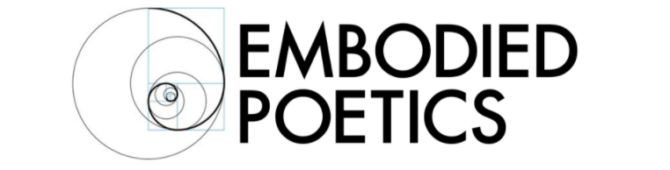

AN EMBODIED POETICS CO-LAB with Lazlo Pearlman and Amy Russell
Beyond the Pale: Transgression and Transcendence in Performance Art

Beyond the Pale is practical workshop in performing the “explicit” body. Everybody and every body is different. To perform “explicitly” is to make this difference known, palpable, relevant, and active. This explicit difference of each person is the grain of sand in the narrow, two-sided clam of hegemonic perception! As you work with the many-splendored devices of Performance Art, Lazlo Pearlman and Amy Russell will help you to create your own unique pearl!

Performing the Explicit Body is not necessarily about physical nakedness or revelation. It is about the ability to perform ourselves as others do not wish to see themselves: as being different. A perfect body performing or displaying itself perfectly or an imperfect body overcoming its limits – these are perceptions that the mainstream finds comforting, as they reinforce the binaries that are the dual engines of normative production: perfection and the redemption of imperfection.
Being an explicitly different body is a powerful performance tool. It has enormous potential as a disruptive force, challenging, among other things, normative notions of identity based in gender and sexuality, ethnicity, age, aesthetics, and ability.
In popular culture ‘Grotesque’ is most often considered synonymous with the ugly, disgusting, and monstrous - the abject Other against which we define the Self. However the word originates in the “grotto” – the ancient site of mystery and of nature’s hidden secrets.
What is hidden and secret about ourselves, what we fear will be judged, these are the powerful revelations that fuel creative performance and inform the subversive impact of Performance Arts. This grotesque self, according to Sarah Cohen Shabot, is in fact the postmodern subject, the actual ambiguous nature of existence itself: “interconnected, intertwined and total,” and at the same time “plural, heterogeneous, dynamic, fluid and changing.”
Lazlo will bring in examples of his own work and that of some of his many performing contemporaries, and will transform your perceptions of the potential of Performance Art to inform your own work as a performer in any discipline of the performing arts. Amy will bring in practical exercises that will provoke you to find, play and perform your difference.
About Lazlo and Amy

Lazlo is a creator, performer, director, lecturer and teacher whose work is often but not always generated by his FTM transgendered experience. He has been making performances since he was a ten-year-old girl, first inspired by an obsession with black and white musicals, comedies and film noir. He has made his way through (and returned to) many performances including physical theatre, performance art, installations, cabaret, burlesque, vaudeville, fetish shows, camp/parody, clowning, film/video and even the occasional piece of “straight” theatre.

Lazlo has created four one-person shows, dozens of solo short works, written and directed short films and has collaborated with and directed many other performing artists. He has taught workshops and given lectures in the US, Canada, France, Italy, Germany and the United Kingdom. Most recent projects include the new show “Dance Me to the End of Love”, a work exploring love, exposure, the trans body, intimacy, vulnerability and partnering and using the strip, dance, performance art and audience participation and the feature length documentary on his work “Fake Orgasm”, which toured festivals worldwide in 2011. His short film “Unhung Heroes” the first comedy about not having a dick, is available through Frameline Distribution and is viewable online.

Amy is the Founder and Pedagogic Director of Embodied Poetics. She is a senior teacher in the pedagogy of Jacques Copeau/Suzanne Bing and Jacques Lecoq. She is also a qualified and accredited Gestalt Therapist (UKCP) and has a solo practice as well as working in group facilitation.

Amy has taught the Embodied Poetics Pedagogy for over twenty years. She was a pedagogic student of Jacques Lecoq in 1997-1998. She went on to found the Naropa Unversity MFA in Lecoq-Based Physical Theatre, which she led and taught for nine years. She pedagogically co-founded the London International School of Performing Arts (LISPA) in 2003. She teaches workshops in the pedagogy, as well as its interface with Gestalt practice at schools and conservatories internationally.

Course Details
June 8.9
Saturday 1 – 9 PM, Sunday 11 AM – 5 PM
Chisenhale Dance Space, 68-84 Chisenhale Road, London E3 5QZ
Fee: £175

Embodied Poetics is a company limited by guarantee
Registered in England number 11185216
Registered Office: Registered Address:
93, Green Dragon Lane, Winchmore Hill, London, N21 2NL, England

